Module 12

Soln- we will perform hierarchical clustering on crime dataset. By visualizing the dendrogram plot of this dataset it is clear that we should make 6 groups of this dendrogram to get balanced grouping, however in one group i.e group 2 , it contains single data which is clustered in the last which means that this data is quite dissimilar with other data therefore it has been kept in separate group.

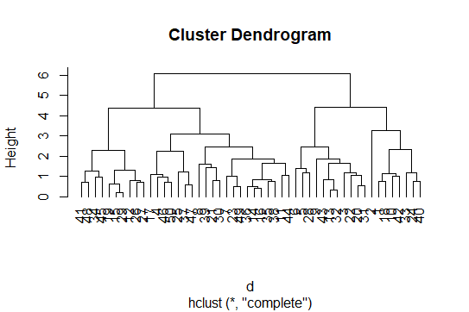

Inferences
- From the crimedata we can observe that crime rates are maximum in cluster 3 countries and minimum in cluster 6 countries.

